
Behaviour Management Policy
(Relational Approach)

Approval date |  | September 2024
Review frequency |  | Annual
Date of next review |  | September 2025
Signed by Headteacher |  | Ella Hughes | 
Signed by Chair of Governors |  | Tim Wheeler | 
Document control
Last reviewed | September 2024
Written by | Karen Pilling (Deputy Headteacher)
Approved by | Debbie Burton (Inclusion & Safeguarding Chair)
Status | Statutory
Published on website | Yes
Main amendments as part of this review / update | - No changes
Links to statutory guidance | - Positive environments where children can flourish - GOV.UK (www.gov.uk)  - Behaviour and discipline in schools: advice for headteachers and school staff, 2016  - Behaviour in schools: advice for headteachers and school staff 2022  - Searching, screening and confiscation at school 2018  - Searching, screening and confiscation: advice for schools 2022  - The Equality Act 2010  - Keeping Children Safe in Education  - Exclusion from maintained schools, academies and pupil referral units in England 2017  - Suspension and permanent exclusion from maintained schools, academies and pupil referral units in England, including pupil movement - 2022  - Use of reasonable force in schools  - Supporting pupils with medical conditions at school
Links to non-statutory guidance | - https://raisingchildren.net.au/preschoolers/behaviour/rules-consequences/  - https://peacemakers.org.uk/resources  - https://www.parentingscience.com/whats-wrong-with-classroom-behavior-charts.html  - https://www.pinterest.com/pin/125608277084229808/
Other documents / resources used in the writing of this policy | - https://www.oxfordshire.gov.uk/sites/default/files/file/children-and-families/PACEforteachers.pdf  - https://www.curiosity-project.co.uk/
Related policies | - Behaviour principles written statement  - Relational Approach Policy  - Child Protection and Safeguarding Policy  - Anti-bullying and harassment  - Positive handling  - Exclusions  - PSHE and SRE  - Staff wellbeing  - Staff Code of conduct

Vision & Missions statement
Making a difference and achieving excellence for every child.

School values
- Growth – We go beyond what is expected to continually improve standards and deliver ambitious outcomes.
- Respect – We do the right thing for our children.
- Inclusion – We care about people as individuals.

You can find out more about school on our website: https://www.chapelstreetprimary.co.uk/

If you have any questions about the content of this policy:
- If you are a member of staff – speak with your line manager or a member of the leadership team
- If you are a parent / carer – contact the school office on 0161 224 1269
- If you are another interested party – contact the school office on 0161 224 1269

If you would like a paper copy of this policy printing for you, please contact the school office who can arrange this.
Aims
- To create an environment that embodies our school’s vision and values and promotes positive wellbeing for all.
- To support all in our school community – including pupils, staff, parents / carers and wider stakeholders – with exemplifying our values at all times.
- To provide a safe, happy and nurturing environment where all individuals have a sense of belonging, are valued and thrive.
- To facilitate all pupils and staff in working towards excellence through high quality challenge and support.
- To assist all pupils and staff in consistently meeting the school’s high standards and expectations for their attitude, behaviour and communication.
- To maintain a calm, purposeful and nurturing atmosphere where all pupils and staff are ready to learn, develop and grow.
- To foster, nurture and value healthy, trusting relationships.
- To develop resilience, through positive relationships, for all pupils and staff.
Underlying Principles
- Positive relationships between all members of our school community are imperative to our practice, buffer stress and build resilience.
- Children and adults have a sense of belonging, feel safe, secure and valued at our school.
- People learn to cope with all aspects of their lives with support from others.
- The importance of fostering social relationships and mutual engagement in a school community.
- Responsibility for one’s own attitude and actions and their impact on others.
- Respect for other people, their views, feelings and circumstances.
- Empathy with the feelings of others – including where they are affected by one’s own actions.
- Fairness and equality.
- Active involvement of everyone in school with decisions about their own lives.
- A willingness to create opportunities for reflective change in pupils and staff.
- Commitment to not engage in behaviours and actions that can bring feelings of shame for others.
- Understanding that ‘all behaviour is communication’ for both children and adults.

Supporting and Encouraging Positive Relationships and Behaviour

Developing a positive relationship between staff and children is a fundamental aspect of high-quality teaching and learning; it promotes a sense of school belonging and encourages children to actively participate in their own development. We are able to assist and develop children’s resilience and ambition, and help them become reflective learners, as well as being there for support and guidance.

By being aware of every child’s individual needs, whether academic or social/emotional, staff provide the necessary support to ensure that children are supported in overcoming their barriers to success. Chapel Street is an inclusive school and as such, everyone in our community must work together to ensure that we meet the needs of all our learners. Often relationships struggle where activities and learning do not meet the needs of learners. Some children have particular challenges through the complexity of their needs; learning, emotional, behavioural or attendance. Through acknowledging these needs, proactively planning for them and responsively adapting provision we facilitate a better relationship.

Staff at Chapel Street positively encourage a culture where all children and young people feel included, listened to, respected, safe and secure. Furthermore, children’s efforts, attitude, achievements and contributions are valued and celebrated. In order to create this environment for effective learning and teaching, there is a shared understanding of well-being, underpinned by children's rights and a focus on positive relationships across the whole school community.

How do we follow a relational approach when responding to behaviour at Chapel Street?
Respect
At all times we greet every child with a smile at the door and use positive body language to re-assure children that we are happy to see them and that they are valued. All our lessons are prepared in advance, and adapted responsively as needed, so that children can engage in learning quickly and successfully. We use a calm, positive and professional manner at all times so that we can role model expected behaviour and reduce any triggers of previous trauma. We use relevant consequences which teach positive behaviour. We know that sanctions are a poor motivator and do not change behaviour in the long term and that children need to be taught how to change their behaviour with relevant consequences. We use ‘logical consequences’ - only imposing a consequence that’s related to the behaviour we want to discourage. For example:

- Being silly and spills her drink, she must wipe it up.
- Not completing work – has to complete it at break time/at home
- Fighting over a toy - the toy is put away for 10 minutes
- Messing around in the toilets – has to be escorted
- Messing in the line - has to walk at front of the line

We do not use shame-based approaches such as, Traffic Lights or names written in public places such as on whiteboards, as we recognise that this can negatively affect children’s self-esteem and relationships, which can in turn increase poor behaviours. We always ensure that consequences teach better behaviour rather than punish it, preserve the dignity of all the parties and are applied in a fair and consistent way. This means that any relevant consequences are proportionate to the nature and seriousness of the behaviour, take account of the cultural background of the student and are sensitive to the particular circumstances of vulnerable individuals or groups of students (for example, a child in care or a child with special educational needs).

Consequences are used as an opportunity to teach a child a skill they may need to develop further, for example if a child is shouting out during lessons do they need additional support to take turns, focus or self-regulate and how can this be facilitated by the teacher. Where possible consequences are also relational, so will involve a trusted adult (and where appropriate other children) to help the child learn and develop. We also consider that a child’s developmental stage may not be in line with their chronological age, for a number of reasons, and ensure that any consequences are developmentally appropriate for the individual child and their needs.

We are consistent in our rules and routines so that all children fully understand all behavioural boundaries and expectations. We remind children of these routines and boundaries throughout the day and at the beginning of a new half term, ensuring the children’s knowledge of them is reinforced. We reward and praise often and acknowledge effort as well as achievement, as we appreciate that all children progress and learn at different ability levels. We always keep parents and carers fully informed of children’s progress, recognising that parents/carers are children’s first educators and have a vital role to play in child development and success.
We ensure that we follow the PACE approach as a ‘way of being’ in all of our interactions, as we recognise that this approach actively communicates empathy and sympathy and acceptance of the individual child, while providing them with the comfort and containment needed to explore feelings and emotions. (See https://www.oxfordshire.gov.uk/sites/default/files/file/children-and-families/PACEforteachers.pdf),

Growth
At Chapel Street we promote our value of growth by providing a diverse range of learning opportunities and developing the skills and knowledge of all learners, whilst also tending to their social, emotional (rather than behavioural) and developmental needs. It is these opportunities that enhance capacity for lifelong learning; emotional, social and academic.

We have ambitious and high expectations for all our learners and value growth through learning from mistakes. This means that all children are supported and encouraged to take appropriate risks in their learning, think creatively and problem solve. All children are provided with well-planned challenge that is appropriate to their developmental stage and takes account of their prior learning, knowledge and experience. We provide all children with opportunities to experience success, in a range of areas, through appropriate support and challenge.
We help children to learn by having a timetable which is clear and consistent and shared with all staff and children. This enables children to feel secure and less anxious about what is coming next. We use a multi-sensory approach to help children access learning, including visuals and ‘hands on’ experiential learning, in order to cater for each child’s individual learning needs. By using simple, easy to understand language, including gestures and visuals, we aim to ensure that children understand what is being asked of them. This is particularly important at Chapel Street as we recognise that a large percentage of our children speak English as an additional language.
In order to ensure that all children are able to grow and learn, we follow a topic- based curriculum, this includes Hook Days and Reflection Days to ensure that learning is fun and engaging and provides meaningful experiences. This means we have a curriculum which children are excited about and want to come to school for. Reflection days develop a sense of pride in hard work as learning is celebrated, valued and shared in creative and meaningful ways.
We understand the importance of the learning environment as an aid to learning and so ensure classrooms are tidy, organised and free of clutter, so children can easily access all learning resources independently and children with sensory needs are not overwhelmed or distracted. We regularly update Learning Walls which help children to consolidate learning.
We celebrate children’s achievements regularly and enthusiastically in a variety of ways. We make sure that praise is specific, meaningful and acknowledges effort and attitude alongside progress made – valuing the process of learning alongside outcomes achieved. Some of the ways we celebrate success include:
- Verbal recognition
- Stickers and certificates
- Positive phone calls / notes home and conversations at drop-off / pick-up
- Sharing with other teachers / staff and classes
- Above and Beyond Walls
- Star of the Week awards
- Inclusion in the weekly newsletter.
We recognise the importance and positive impact of pupil voice, pupil leadership and pupil’s taking responsibility for wider areas of school life. For example, through School Council, having designated ‘jobs’ within the classroom such as helping with giving out books or collecting in resources and roles including school librarians, Prefects, Head Boy and Head Girl.
Most importantly, we use adaptive and responsive teaching to ensure that we know what children have learnt and any areas that they still need to develop. This enables us to assess where children are and build on their knowledge. By ensuring that all children are working within their proximal learning zone and are able to achieve success, we foster a love of learning and an enthusiasm to be the best they can be.
Inclusion
To promote the value of Inclusion at Chapel Street, we use trauma informed and attachment aware approaches to support children’s emotional well-being and we ensure that we meet the needs of individual children however complex these needs may be. We recognise that these needs may mean some children struggle to access the same provision as others and so we adapt our teaching and curriculum accordingly.
We recognise that all behaviour is communication and that what can sometimes appear as a poor behaviour choice can often be a symptom of something far more complex and distressing to the child. We seek to understand and support the communication that is hidden beneath the behaviour. We adapt our teaching approaches to ensure that we help the child to meet their need in a more positive way. We use specific strategies to support children with neurological or developmental conditions which may affect their ability to follow school rules (see appendix 2, 3 and 4).
All staff engage authentically in the restorative justice approach to deal with disagreements (Appendix 1) including any instances of bullying or discrimination, as this teaches children the impact their behaviour has on others. We use the restorative justice approach, so the child’s experience of this allows them to develop their own skill to solve future disagreements. We ensure that this is used consistently and use a collaborative, multi-agency approach across the school.
How we support children displaying low level behaviours
At Chapel Street we recognise that positive relationships allow Quality First Teaching strategies to be more effective. We are not able to be prescriptive in our approach to low- or high-level behaviours as our approach will depend on the individual needs of the child and the specific context of each incident. When dealing with any behaviours we consider our knowledge of the child and what their behaviour may be telling us. We also seek to identify any patterns, trends or triggers in relation to a child’s behaviour and take positive action in response to these. We are proactive in anticipating potential challenges for a child and taking steps to prevent an issue from arising.
We recognise that low level behaviours are often an avoidant technique, and so to reduce this we may;
- Employ the PACE approach and use ‘Connection before Correction’
- Deploy staff in the classroom to re-focus the child
- Ensure that the child is able to access the work independently and there is an appropriate level of challenge
- Use distraction/humour to re-engage the child back into their learning
- Re-position the child to help re-focus if needed
- Give the child a sensory break if needed – e.g. send them on an errand, ask them to do a job
- Celebrate children making positive choices so that children can recognise and continue to make the right choices in future
- Use ‘fair directed choices’ to avoid any escalation
- Use non-verbal gestures/visuals to re-engage the child without disrupting the rest of the class
- Use clear, concise instructions – not engaging in discussion which enables the child to continue avoiding engagement.

How to support children displaying high level behaviours
We recognise that high level behaviours may be due to external factors that are beyond our control such as safeguarding concerns in the home or neurological and developmental difficulties. As well as employing all of the above, and specific strategies as set out in the appendices, we may also;
- Ensure that we prepare children of any upcoming changes which may dysregulate their well-being, these may include changes to routines and timetables, school visitors, parties, celebration days etc.
- Have an awareness of the ‘Time Intensity Model’ and if children do become dysregulated, we use de-escalation and grounding techniques to allow time for children’s cortisol levels to reduce and re-balance.
- Understand that some children are unable to self-regulate their own emotions and so we first co-regulate and then discreetly teach these children self-regulation techniques through daily classroom teaching and specific intervention.
- Recognise and ensure that other children understand that specific interventions are not a ‘reward or treat’ for poor behaviour but a way to explicitly teach children how to make the right choices.
- Use de-escalation techniques at all times and remain calm when dealing with any incidents.
- Following an incident staff will record the incident on CPOMS, using ‘Trigger, Action, Response’ format, in order to identify patterns and trends, so appropriate support can be put in place. They will also inform parents/carers at the earliest opportunity.
- Following a serious incident, staff will de-brief with a member of SLT to identify and antecedents and any changes to provision needed.
- 1:1 sessions based on areas of need identified through Boxall Profiles
- Recognise that pastoral interventions are providing necessary pastoral support and so cannot be taken away or reduced as a way to sanction children with social, emotional or mental health needs. These interventions may include but are not limited to;
- Lego Therapy
- Play Therapy
- Nurture Group
- Quiet Club
- Forest School sessions

How we support staff well-being
We recognise that traumatised children often try to control the emotions of the adults in their lives. This climate of aggression is much more familiar to them than calm, considerate interactions. Practices that help teachers remain calm and avoid the power battles, will be most effective.
To support staff well-being at Chapel Street we work collaboratively, ask for help and support each other. We discuss with other staff how they manage classes/children and learn from each other - sharing expertise and good practice. We have a Relational Approach policy for whole school and our line management process is based on a coaching and mentoring to support this.
We have regular CPD for staff on how to promote children’s well-being and how to support children’s individual needs. All staff have attended training on Attachment, Trauma and De-escalation techniques.
We have a Play Therapist on site, who runs drop in sessions and supervision for staff in order to talk through strategies and reduce the impact of children’s behaviours on their well-being. We also have ‘staff buddies’ who specialise in a particular area of SEND and can advise on resources and suggest strategies.
We have a Well-Being Team in school who support the well-being of staff with information sharing, signposting and regular well-being updates – in line with our whole school well-being strategies and policies. We also have a mental health lead for pupils and staff who are trained in mental health first aid for both adults and children.
Staff are able to access practical support through a variety of ways including, but not limited to;
- The SENCO
- Supervision sessions
- Pastoral TA
- PRU and Grange Outreach services
- Speech Therapy
- Educational Psychologist
- EAP service provided by school
- Wider leadership including phase leads and senior leaders.

The Senior Leadership Team ensures that staff well-being and work life balance is always given high priority in any decisions that are made. This package of support ensures that staff at Chapel Street feel valued and supported and are able to meet the needs of all children including those with complex individual needs.
In addition to the strategies and resources provided in these appendices please also see those in the ‘Relational Approach’ policy.
Appendix 1 How to have a restorative conversation
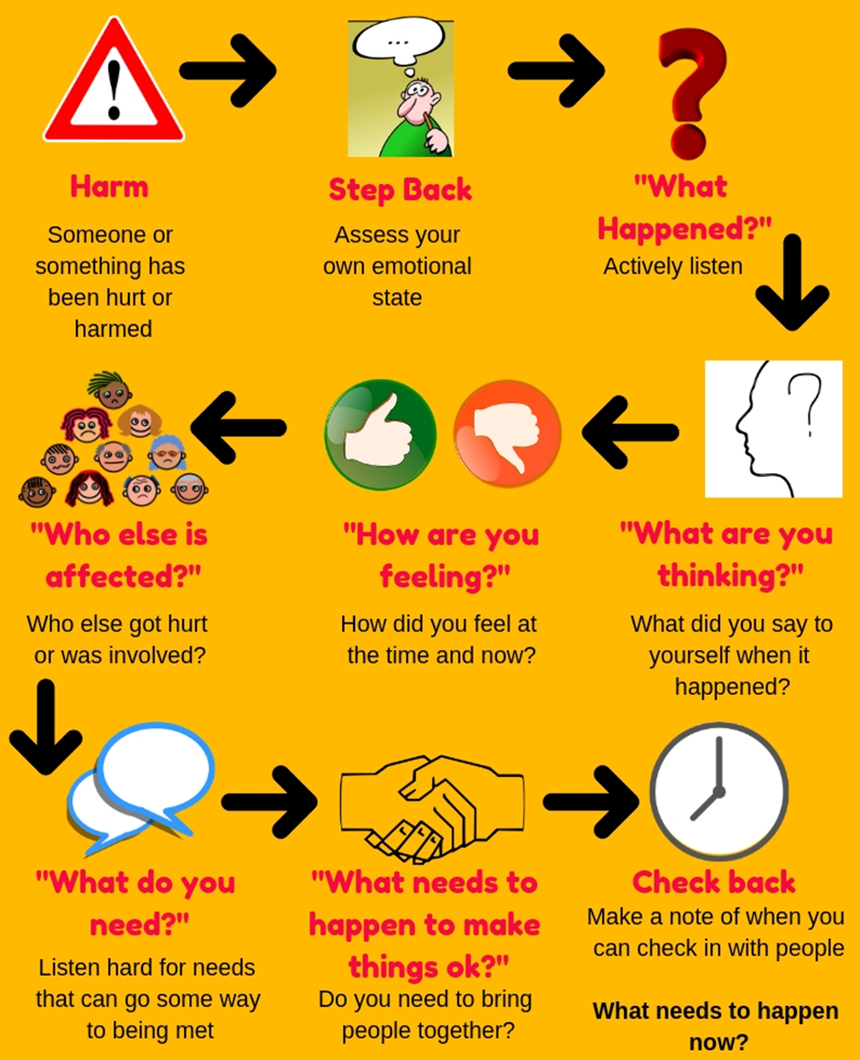

Appendix 2 – Suggested strategies to support the needs of children with Attention Deficit Hyperactivity Disorder (ADHD)
- Seat the child near the teacher but include them as part of the regular class
- Place the child up front with their back to the rest of the class, keeping others out of view
- Use Tangle Toys, Wobble cushion, foot rolls to help the child concentrate
- Surround the child with good role models
- Encourage cooperative learning but avoid seating children with ADHD in large clusters of tables with lots of children at each.
- Avoid distracting stimuli. Try not to place the child near heaters, doors or windows or other potential distractions, high levels of traffic or background noise can also be a problem
- Try to avoid changes in schedules, physical relocation or unnecessary transitions. These children do not respond well to change or unplanned activities, so monitor them closely on extra-curricular activities such as trips
- Maintain eye contact/ physical contact with them during verbal instruction
- Make directions clear and concise and be consistent with daily instructions
- Make sure they understand instructions and what is expected before beginning a task
- Gradually try to reduce the amount of assistance the child receives
- Give one task at a time, monitoring frequently and modifying assignments as necessary
- Consider the use of headsets/workspace dividers to provide a proactive distraction when appropriate
- Break tasks down into manageable chunks
- Allow movement breaks/time out cards during class time and give child planned and regular sensory breaks
- Give child daily responsibilities (jobs in and out of the classroom) to improve their self-esteem
- Make appropriate use of computerised programmes and resources for specific learning objectives
- Offer choices. Children with ADHD who are given choices for completing an activity produce more work, are more compliant, and act less negatively. Use ‘Fair Directed Choice’ technique to avoid confrontation.
- Provide visual reminders. Children with ADHD respond well to visual cues and examples. When children get to their independent work, leave key points/vocabulary about a topic visible on the board. Post important concepts the children will use again and again on brightly coloured posters board around the room.
- Increase active class participation. Group strategies include asking children to write their answers on dry-erase white boards and showing them to the teacher, asking children to answer questions in unison (choral response), having children give a thumbs up or down if the answer to the question is yes or no — a level palm, if they don’t know the answer.
- Reaffirm your availability constantly (eye contact, tap on the shoulder) Let them know that you are ‘keeping them in mind’.
- Encourage hands-on learning. Create practical learning opportunities where children experience things first-hand. Have students write and act out a play, record an assignment on videotape.
Appendix 3 – Suggested strategies to support children with Autism Spectrum Disorder (ASD)
- Know the child - this means you can identify triggers and motivators
- Use visuals as much as possible, (even if you think the child doesn’t need it/respond to them) to help children understand instructions.
- Ensure you have consistent timetables and routine. This reduces anxiety for children with ASD.
- Plan and warn child of any upcoming changes – the more notice the better (even if the change seems like something the child will enjoy).
- Simplify tasks. Many children with ASD can only follow one or two instructions at a time.
- Simplify language.
- Use Tangle Toys/stress balls when needed to help the child focus and concentrate.
- Use Task Boards with clear instructions and pictures to ensure the child knows what to do.
- Link learning to interests – many children with ASD have a particular interest and these can be a great motivator.
- Always say child’s name when giving instructions as they can be overwhelmed in a class full of 30 children and not realise that you are speaking to them.
- Consider the use of headsets/workspace dividers to provide a proactive distraction when appropriate, or a ‘Break Out’ space.
- Make appropriate use of computerised programmes and resources for specific learning objectives.
- Plan for ‘flash points’ and ensure risk assessments are in place (fire alarm, trips etc.) so that staff know what to do if children become dysregulated.
- Give the child daily responsibilities (in and out of the classroom).
- Allow movement breaks/time out cards and plan regular sensory breaks.

Appendix 4 – Suggested strategies to support children with Social, Emotional and Mental Health difficulties (SEMH)
- Know the child so that you can identify triggers and motivators.
- Ensure you give a positive greeting and body language at start of lesson. Children with SEMH are hyper-aware and will pick up on any negativity.
- Think about seating. Do they work better next to certain children? Ensure they are sat with a clear exit so they can have time out of needed without disrupting the rest of the class.
- Understand the child’s triggers. If a child becomes wound up/anxious allow him/her to remove self to an agreed calm-down area or use a task box.
- Make instructions short and clear.
- Set tasks with clear goals, outputs and timescales. Once this has been agreed do not change.
- Teach the child specific behavioural skills, e.g. how to ask for help, how to line up.
- Make an effort to ‘catch the child being good’ and praise them. Ensure that this is sincere! Children with SEMH will know if it is not and this will reduce their trust in you. Praise the action, not the child.
- Devise a private non-verbal signal system to let the child know when they are off task or behaving inappropriately. This reduces shame for the child.
- Find out what they know about or are good at, and have them share this with the rest of the class or school/support another child.
- `Give them responsibilities, for example organising a lunchtime or after-school club, being a playground buddy, helping those who are new to the school.
- Photocopy good pieces of work for them to take home/put up (if child likes praise).
- When things go wrong, reject the behaviour, not the child… ‘This is not the behaviour I expect to see from someone as kind and helpful as you’
- Reaffirm your availability constantly (eye contact, tap on the shoulder) Let them know that you are ‘keeping them in mind’.

