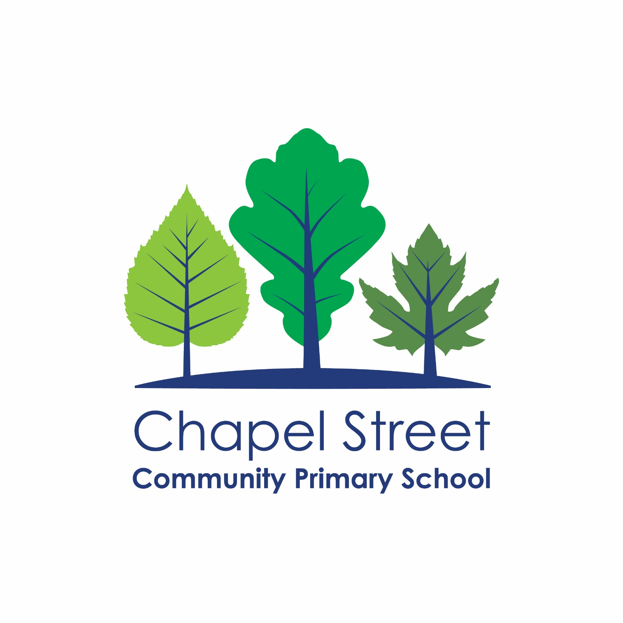

**Writing Policy**

|  |  |  |
| --- | --- | --- |
| **Approval date** | December 2023 | |
| **Review frequency** | Triennial | |
| **Date of next review** | December 2026 | |
| **Signed by Headteacher** | Ella Hughes |  |
| **Signed by Chair of Governors** | Tim Wheeler |  |

|  |  |
| --- | --- |
| **Document control** | |
| **Policy title** | Writing Policy |
| **Last reviewed** | 1/12/23 |
| **Written by** | Writing Lead |
| **Approved by** | Headteacher |
| **Approval date** | 1/12/23 |
| **Recorded at** | Full Governing Body |
| **Date of meeting** | 13/12/23 |
| **Staff consultation** | N/A |
| **Review frequency** | Triennial |
| **Date of next review** | December 2026 |
| **Status** | Non-statutory |
| **Published on website** | Yes |
| **Main amendments as part of this review / update** | * Updated with changes to whole school Curriculum. |
| **Links to statutory guidance** | * Statutory framework for the early years foundation stage: Setting the standards for learning, development and care for children from birth to five * The National Curriculum in England – Key Stages 1 and 2 |
| **Links to non-statutory guidance** | * The Key – model policy advice * <https://www.oxford-grove.bolton.sch.uk/information/curriculum/> * Model policy |
| **Other documents / resources used in the writing of this policy** | * Support from One Education |
| **Related policies** | * Teaching and Learning Policy * Feedback and Marking Policy * Assessment Policy * SEND policy * Spelling policy * Handwriting and presentation policy |

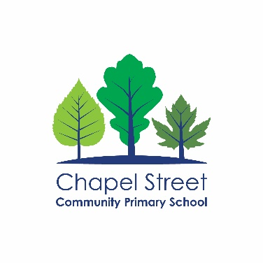

**Vision & Missions statement**

Making a difference and achieving excellence for every child.

**School values**

* Growth *– We go beyond what is expected to continually improve standards and deliver ambitious outcomes.*
* Respect *– We do the right thing for our children.*
* Inclusion *– We care about people as individuals.*

You can find out more about school on our website: <https://www.chapelstreetprimary.co.uk/>

If you have any questions about the content of this policy:

* If you are a member of staff – speak with your line manager or a member of the leadership team
* If you are a parent / carer – contact the school office on 0161 224 1269
* If you are another interested party – contact the school office on 0161 224 1269

### Intent

At Chapel Street Community Primary School, we recognise that writing is integral to all aspects of life and we work to ensure that children develop a lifelong, healthy and enthusiastic attitude towards writing.

The overarching aim for English in the National Curriculum is to promote high standards of language and literacy by equipping pupils with a strong command of the spoken and written word, and to develop their love of literature.

But at Chapel Street, we aim to do more; we want our children to become engaged and passionate writers. Our school motto is to ‘respect everyone; grow together’ and through our Writing curriculum, we provide opportunities for all learners to grow and work collaboratively in a respectful way. We want our learners to become independent writers who are confident at taking risks with their writing, building their knowledge over time as authors.

During their time at Chapel Street, children have the opportunity to explore progressively more complex text types and genres, building on their prior learning. However, we understand that in order for this to happen, children must first be taught early writing skills, including a key focus on transcription, prioritising links to Phonics knowledge through developing spelling and handwriting. Over time, as children develop confidence, we gradually introduce more complex language and encourage them to investigate and explore how language works. We want all children to see themselves as authors, developing an awareness of writing and how to adapt their writing for any intended audience or purpose. To this end, we place value on the teaching of language and grammatical structures in context throughout school, building children’s ability to talk confidently about their writing and the choices they make as writers.

We believe that no child should be left behind in Writing and so place emphasis on rigorous teaching and additional support for those that need it. Every child should leave Chapel Street with the Writing skills they need to access their next steps in life.

### Implementation

At Chapel Street we use carefully chosen texts to inspire and facilitate children to engage with increasingly complex writing opportunities during their time at school. We have developed our approach to support progression in learning and build on children’s experiences and prior knowledge.

**Texts**

At Chapel Street we ground our writing curriculum in the exploration of a wide range of high-quality texts, to inspire and facilitate writing opportunities, stimulating children’s interest and providing role models for writing. We choose texts carefully to support children’s learning, making links between content. Throughout their time at Chapel Street children will engage with texts that:

* Stimulate their curiosity, interest and engage them, develop opinions and preferences.
* Expose them to a wide range of vocabulary and language.
* Widen their experiences and develop their cultural capital.
* Build their understanding of key themes.
* Encourage them to engage with different perspectives and viewpoints.

To do this we choose key texts, which form the main stimulus for writing, however these are supplemented by supporting texts. These include fiction, non-fiction, poetry and plays. These texts are used both within the teaching of Writing, and in the teaching of Reading to broaden children’s knowledge and experience.

### Impact

Writing in our school is progressive, challenging and planned to meet the specific needs of our children. We are ambitious and we strive for the best possible outcomes in writing for all our pupils. Monitoring and pupil feedback tell us that our children are enthusiastic, independent and reflective authors who can write for a wide range of purposes and audiences, using appropriate transcription and composition knowledge.

To support teaching and learning, assessments and subsequent analysis are carried out regularly which enables us to measure and monitor the impact of our writing curriculum. This information is combined with regular *Pupil Progress* meetings to ensure all children are appropriately challenged, with intervention put in place promptly for those who need it.

The implementation and impact of the writing curriculum and how it reflects this policy is reviewed throughout the year in a range of ways by different stakeholders. The Writing Lead regularly monitors and evaluates the teaching and learning of writing in Year 1 to Year 6. They also meet regularly with the appropriate EYFS lead for English Literacy, Communication and Language to monitor and evaluate provision in EYFS. We also use feedback from staff, children, parents and the wider school community to inform this review. At statutory assessment points, this review will also be influenced by assessment data and moderation.

### Writing Outcomes

We recognise the importance of children writing for real-life purposes and developing enjoyment in writing for a range of reasons and audiences. During their time at Chapel Street, children have the opportunity to explore progressively more complex text types and genres, building on their prior learning. These range across fiction, non-fiction, poetry and plays.

We have developed our writing outcomes to support children’s starting points as well as providing opportunities to teach the requirements of the National Curriculum. Our outcomes are designed to build on prior learning, both from previous year groups and within each year group. Throughout each year, children are given the opportunity to engage with text types and genres multiple times to build confidence and encourage the application of skills, including through disciplinary literacy. We value the importance of children writing for real purposes and audiences; therefore, we use our RAFT structure to unpick each outcome in more detail.



### Early Writing in EYFS

In EYFS we focus on building firm foundations in the basic skills. To ensure this, children are provided with an environment that focuses on the EYFS prime areas C&L, PSED and PD without which, children cannot access the writing curriculum. This looks like developing fine and gross motor skills, supporting children’s emotional wellbeing and giving ample opportunity to develop speaking and listening skills. We look to the skills progression map to plan for and support all classes.

Children in EYFS receive daily group input and guided sessions. Children get the chance to practice taught skills independently in the continuous provision. We give meaning and purpose to writing both during group time and in the continuous provision to ensure learning sticks. We encourage writing in all areas of the curriculum and seek all opportunities to develop writing skills such as using the outdoor area to mark make and write.

We ensure high quality modelling by adults, well organised resources and appropriate intervention so children can access the writing curriculum without any barriers.

|  |  |
| --- | --- |
| **EYFS** | |
| Within the EYFS at CSCPS, we pride ourselves on providing a broad and well-balanced curriculum. Our specific areas of learning and characteristics of effective learning are developed through well planned, motivational activities within Continuous Provision and Carpet Times. | |
| **In play:** | * Daily opportunities to develop fine and gross motor skills. * A variety of resources and equipment to support writing and mark making in different ways, such as pens, paint, chalk, paper, whiteboards etc. * Inviting and engaging stimulus to inspire ideas for writing and mark making. * Opportunities to share their mark making and writing with an adult and give meaning to the marks they make. * Writing for purpose in areas such as the role play, maths, creative and investigation area. |
| **In groups:** | * Daily name recognition, name building and name writing activities. * Fine and gross motor carpet sessions such as dough disco and scarf dancing. * At least weekly guided writing sessions linked to the topic and supported by an adult. * Adult directed writing challenges. * Opportunities for writing during Reception phonics lessons in the form of spelling in Autumn and writing sentences in Summer. |
| **Outcomes:** | * Mark make, draw and write freely. * Talk about and give meaning to the marks they have made. * Write and mark make their name. * Use phonics to identify sounds and link them to letters when writing. * Write short sentences and captions. |

### Developing Writing in KS1 and KS2

Across the rest of the school, we build on children’s learning from EYFS, with a particular focus on using and applying their initial Phonics knowledge in writing. All classes are taught daily for a minimum of 1 hour through a whole class approach to Writing. All writing units have as their focus a carefully chosen text which links to the specific text type being taught. Teaching follows the school’s writing teaching sequence, with each unit lasting 2 weeks. This means that every half term, children are given the opportunity to write at least three extended pieces of writing as outlined on the school’s long-term plan. Writing lessons prioritise links to the teaching of Reading and Oracy, as well as specific teaching of transcription*, composition and the metacognitive aspects of writing.

At Chapel Street we focus on developing children’s transcription and basic skills throughout writing teaching. As part of this, we begin each term by teaching the basic skills children need to improve their writing, before we move on to applying these in writing using our school teaching sequence:

|  |  |  |  |  |
| --- | --- | --- | --- | --- |
| Day 1 - Hook and Features  Engage pupils and activate background knowledge.  Share front cover and blurb.  Questioning is used to support pupils to make connections to their prior learning and prior reading.  Any gaps in background knowledge central to the text are addressed.  Begin reading the text with the pupils. Chance to ask questions, make predictions and address misconceptions. | Day 2 – Features  Discuss and introduce features relating to text type  Introduction of what the genre is, how and why it is used.  Identify children’s prior knowledge of the genre through discussion.  Introduce WAGOLL text – same genre/text type covered in lessons  Children create a mind map of the features in their book.  RAFT introduced and completed with the class | Day 3 – Key skill  This session focuses on a specific grammatical concept that is important to the RAFT of the outcome.  The session gives opportunities for children to investigate language, as well as teaching, practising and applying key grammatical concepts.  Please see progression document to support identifying age appropriate skills. | Day 4 – Key Skill  This session focuses on a specific grammatical concept that is important to the RAFT of the outcome.  The session gives opportunities for children to investigate language, as well as teaching, practising and applying key grammatical concepts.  Please see progression document to support identifying age appropriate skills. | Day 5 - Key Skill  This session focuses on a specific grammatical concept that is important to the RAFT of the outcome.  The session gives opportunities for children to investigate language, as well as teaching, practising and applying key grammatical concepts.  Please see progression document to support identifying age appropriate skills. |
| Day 6 – Plan  Children should be given the opportunity to plan their writing using a planning sheet every time they write.  Planning should always focus on both the content and language features of the writing outcome, based on the RAFT.  All planning lessons will refer back to the RAFT and be focused on modelling making choices as an author as to what to include in writing.  Over time, the aim is for children to become adept at choosing which content to take forward from their learning to make their writing as effective as possible. | Day 7 – Draft  Every writing lesson should begin with a modelled focus where a key aspect of the writing is demonstrated using thinking aloud by the teacher.  This might focus on a particular section/paragraph, or it might unpick a more specific feature of the genre, e.g. using cohesive devices, or using capital letters for proper nouns.  Following targeted modelling from staff, the expectation is that children work independently, with support as needed. | Day 8 – Edit  After writing, the expectation is that the class peer and self-assess their writing.  If necessary teachers can edit with a small group of children who require more support.  Any changes that the children want to make to their writing should be done in purple pen.  The aim of this lesson is to address misconceptions and provide children with the opportunity to refine their writing.  The class be can provided with an editing checklist which has been informed by the RAFT. | Day 9 – Big Write  A Big Write learning slip must be stick into big write books.  The learning slip should include the date, reason for writing (to write a persuasive letter) and the RAFT.  Children should work independently to complete their Big Writes.  Children can use their drafted piece of writing. Ensure the children include their edited notes in purple pen. | Day 10 – Edit  After completing the big write, the expectation is that the class peer and self-assess their writing.  Any changes that the children want to make to their writing should be done in purple pen.  The aim of this lesson is to address misconceptions and provide children with the opportunity to refine their writing.  The class be provided with an editing checklist which has been informed by the RAFT. |

In Key Stage One, children need additional support throughout the writing cycle so the plan and draft is often a shared write. Staff can be flexible with the cycle depending on the genre and needs of the pupils. Changes to the cycle should be discussed with the writing lead.

We understand the importance of children being able to apply their writing knowledge right across the curriculum for different purposes. Transcription and composition are reinforced every time children write, no matter the subject, with children being given regular opportunities to write in every subject on a sentence and paragraph level. When appropriate to the subject content being taught, children are given the opportunity to write an extended piece of writing to show their disciplinary understanding.

### Children Who Need Additional Support

We identify children who are risk of falling behind in writing quickly, and put in place additional support to meet their specific needs. Depending on each child’s specific needs, this support may be within the classroom or working with an adult on an intervention programme. Within the classroom, this support will be through adaptive teaching, including scaffolded prompts, word banks or working with adult support. Pre-teaching is used to help children to prepare for new learning, particularly when teaching vocabulary and grammar. Recap and review is also a key part of our approach at Chapel Street, enabling children to re-visit learning and staff to address misconceptions quickly as part of the learning process. If a child is identified as needing additional support above and beyond this, an appropriate intervention is put in place in a timely manner.

When a child, for whom English is not their first language, joins the school, we recognise and celebrate skills that they have learnt in their own language or a target language of the country they once lived. We offer a wide variety of opportunities for these children to transfer skills from one language to another and assess their phonetical awareness. Initially additional support for these children is primarily focused on Phonics, as the primary route to reading and writing. As children gain confidence in English, they may access other interventions as needed.

For more information on how we support the needs of children with SEND and those in vulnerable groups, please see our SEND policy and Pupil Premium documentation.

### Creating a Writing Culture

At Chapel Street, we recognise the importance of creating a writing culture, where every child is encouraged to build a love of Writing. To support this, we celebrate writing throughout the school in a number of ways:

* Pupils are encouraged to articulate the fact that they are part of a ‘*Writing School’*.
* The whole school environment prioritises writing and aims to inspire children to write. This includes displays of pupils’ writing from every year group which is updated regularly.
* Quality pieces of writing are celebrated within the year group, in assemblies and online.
* Authors visit our school (in person or virtually) and share their writing process with the pupils.
* Pupils enter writing competitions.

### Assessment

Assessment is an integral part of teaching and learning at Chapel Street. We recognise that assessment must be purposeful giving us the information we need to plan appropriately for the needs of our children. Therefore, we use a range of formative and summative strategies regularly throughout the year.

* **Formative assessment:** We continually assess our pupils during lessons through talk and observation. Staff use this day to day information to adapt current provision, plan further work and set new targets.
* **Feedback:** Children are given constructive and timely feedback on their writing in line with our assessment policy. This includes verbal feedback as well as regular self and peer-assessment opportunities.
* **Summative assessment:** The overall attainment and progress of children is assessed and recorded three times during the school year on insight. This information used to inform this assessment includes teacher assessment of Big Writes, daily work in writing sessions and the application of writing in other areas of the curriculum. Assessment judgements are regularly moderated, with the data being used to set pupil targets and identify priorities for intervention. This is conducted in line with the school’s agreed assessment procedures. Pupil progress meetings, take place termly, in which children’s progress, achievements and areas for development are identified and steps put into place to close any gaps.

For children in EYFS, they will be assessed using the Early Years checkpoints and ‘Early Years Foundation Stage Profile’ criteria. Assessments will be on-going throughout the year in this phase. See the Early Years policy for more information.

Please see our assessment policy for more information on how assessment is conducted at Chapel Street.